Episode 411: Describing magnetic fields

The field around a permanent magnet should be familiar to your students. In practice, where we want a controllable field, we use electromagnets. In this episode, students learn about these fields and the factors that determine their strength and direction.

Summary
Demonstration and discussion: The field around a permanent magnet. (20 minutes)
Student experiment: Field plotting. (20 minutes)
Student questions: Revision questions on magnetic fields. (20 minutes)
Student experiments: Measuring flux densities. (30 minutes)
Discussion: Mathematical formulae. (10 minutes)
Student questions: Calculating flux density. (10 minutes)

Demonstration and discussion:
The field around a permanent magnet.
Your specification may require the study of the magnetic field due to a permanent magnet but even if this is not the case, such work forms a good introduction to magnetic fields.
The use of two permanent magnets will remind students that there is a magnetic field around each magnet. (This can be done quickly with an OHP or by allowing the students to experiment with a pair of magnets.)
N
S
(resourcefulphysics.org)

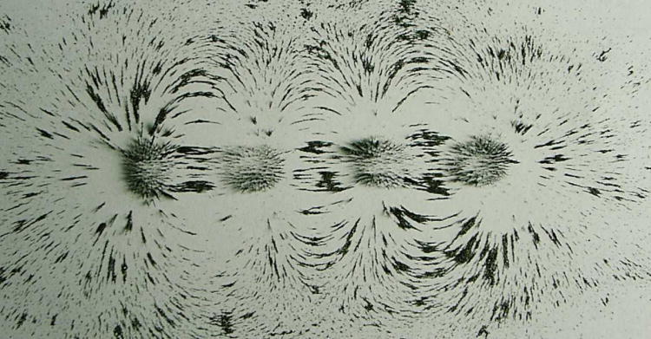
(Advancing Physics)

Like other fields, the magnetic field is a way of describing a region of space where other magnets will experience a force. It can be represented by field lines that show both the size and direction of the force.
How is the field strength represented?
- By the spacing of lines.
How is its direction shown?
- By arrows showing the direction a compass points or 'free north pole' moves.
Can we find a ‘unit’ or ‘free’ pole? No.
A discussion of why not will introduce/remind students of magnetic domains.
If there is no 'unit pole', then in any definition of the magnetic field, it is not possible to simply extend the idea of unit charge/mass found in electric and gravitational fields.
How can we show up magnetic fields? This gives the opportunity to do some field plotting with iron filings or plotting compasses. There may be a computer program available to extend this further.

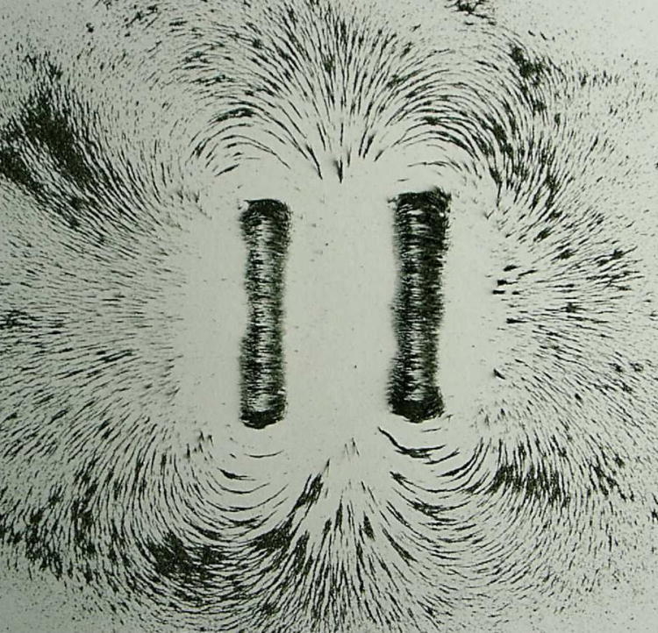
(Advancing Physics)
If your specification requires it, then this is a good time to define neutral points as places where two or more fields cancel out.

Student experiment:
Field plotting
Having covered magnetic fields for permanent magnets, you can move on quickly to revise the basic magnetic field patterns due to the electric current in a long straight wire, small flat coil and solenoid. Again, this revision is a reminder of pre-16 ideas and demonstrations.
Students can look at some field patterns. If you use the worksheet, you will have to explain that flux is a new term that, for the moment, is simply being used as another word for the field pattern. Its significance will become much clearer quite quickly and it would probably confuse students if a more formal approach were used at this stage. The work is useful because it introduces alternating fields from an alternating current and shows how a search coil can be used to investigate these.

TAP 411-1: Magnetic field shapes seen as flux patterns

For some specifications, this will serve as a good revision of the basic pre-16 ideas used to describe magnetic fields and it will be possible to move quickly on to the idea of flux density and the force on a conductor.

Student questions:
Revision questions on magnetic fields
The ideas covered above can be reinforced with an activity based on using magnets in automatic train protection. One section suggests that students ‘check that’ but this could be made into a written exercise before a couple of questions are attempted.

TAP 411-2: Brush up on magnetism

Some more questions, revising basic ideas about magnetic fields.

TAP 411-3: Magnetism reminders

Student experiments:
Measuring flux densities
Some specifications require a more detailed investigation of the magnetic fields due to currents.
Your students should be able to measure the fields due to a long straight wire (sometimes a difficult experiment in which to get good results), a small flat coil and a solenoid. There are many possible approaches and the choice of apparatus will depend on what you have available. A calibrated Hall probe is useful, but the nature of the relationships can be deduced with ac and a search coil. (If you use a calibrated probe then you will need to explain that the unit for field /flux density is the tesla (T) and that this will be defined very soon.)
A

(resourcefulphysics.org)
oscilloscope
Whichever flux measurement technique is available, you need only set your students the task of establishing how the flux density depends on the current flowing and the distance (radial distance from a long wire, and along the axis of a flat coil or solenoid).
Search coil

TAP 411-4: Fields near electric currents

Discussion:
Mathematical formulae
For a long, straight, current-carrying wire, students will probably find that the field is proportional to the current but the 1/r relationship for distance is not always easy to confirm. Offer them the equation B = µ_{o}I/2πr where µ_{o} = 4π × 10⁻⁷ N A⁻² is a constant known as the permeability of free space, and ask if their results are compatible with this.
For a solenoid, students should be able to check the relationship of field to both current and the number of turns per unit length.
Hence B = µ_{o}NI/L
The mathematical formula for the field for a small flat coil is not required.

For a coil wound around iron field is given B = µNI/L where µ depends on the type of iron or other magnetic core material

Student questions:
Calculating flux density

TAP 411-5: Flux and flux density

TAP 411-1: Magnetic field shapes seen as flux patterns

You will need:
✓ bar magnet
✓ pair of slab magnets mounted on a yoke
✓ small button magnet
✓ collection of shaped permanent magnets
✓ long wire
✓ power supply, 0–12 V, (a Westminster Very Low Voltage power supply is designed for this work)
✓ 240-turn coil
✓ C-core
✓ 1100-turn coil
✓ long coil
✓ slinky spring, metal
✓ gimballed bar magnet
✓ iron filings
✓ plotting compasses
✓ multimeter

Exploring fields
1. First remind yourself of the pattern around a permanent bar magnet. Place the bar magnet under a piece of paper. Scatter iron filings on top. Tap the paper gently to obtain what will probably be the familiar ‘butterfly pattern’.
2. Use the gimballed magnet to explore the flux around the other permanent magnets. Try to record your results by sketching the flux lines in three dimensions.
3. Connect the long straight wire to the dc supply. Place a plotting compass a few centimetres away from the wire. To explore the field around the single long straight wire: vary the current, move the compass around the wire and change its distance from the wire.
4. A slinky spring can be used as an air-cored electromagnet of varying turns per metre length if it is connected to the dc supply. Explore the field using the gimballed bar magnet and the plotting compasses. Vary the number of turns per metre length and the current through the slinky.

What you have seen
1. Field lines do not cross.
2. North poles are places where large amounts of field (flux) leave an object, south poles where large amounts enter the object.

Practical advice
This is a simple activity. The point really is to revise the idea of magnetic field lines, seen as flux paths in electromagnetic machines. Clearly any selection of permanent magnets and electromagnets can be explored and any method can be used to explore them. The idea of field lines not crossing but forming closed loops is the one to emphasise.
It is often difficult to get sufficient current through a single wire to explore the field thoroughly. Many low voltage power supplies will produce a strong 100 Hz ripple at high currents which may mask changes. We suggest a high current rheostat in series with the supply and a high current smoothing unit on the supply.

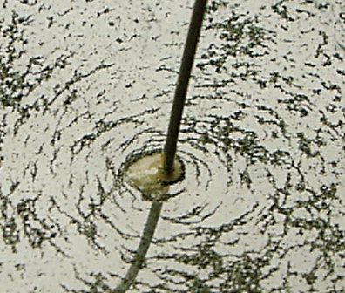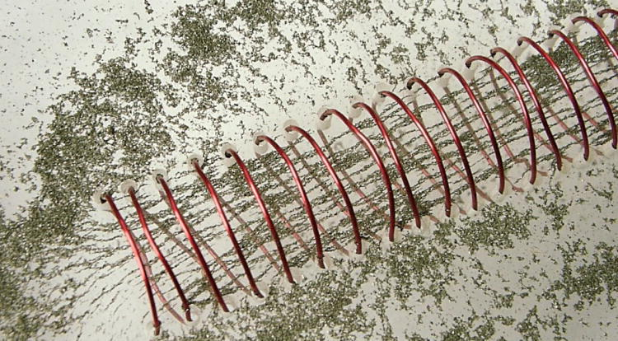

Alternative approaches
There are modern computer programs that help visualise field lines. Alternatively the whole thing could be done quickly by demonstration. The iron filings can be done on an OHP and fixed using hair spray. Chains of paperclips can show the field of a large horseshoe magnet.

External reference
This activity is taken from Advancing Physics chapter 15, 40E

TAP 411-2: Brush up on magnetism

Use some permanent magnets and a current-carrying coil to review your knowledge of the nature and behaviour of magnetic fields. The purpose of this sheet is to help you to brush up your knowledge of magnets before you learn how magnetism is used with trains.

Apparatus
✓ bar magnet with S pole labelled
✓ soft-iron rod (length to match that of magnet) (Philip Harris Q67510/8)
✓ 26 swg PVC-covered copper wire
✓ plotting compass
✓ cardboard/hardboard sheets
✓ 5 V dc power supply
✓ wire strippers

Use the apparatus to plot magnetic fields for a bar magnet, straight wire and a solenoid

Check that you can:
- identify the poles of a bar magnet, a horseshoe magnet and a solenoid;
- describe briefly how to make an electromagnet;
- sketch the pattern of the magnetic fields around a single wire, a flat coil and a solenoid;
(Remember, all lines of force must have a direction. Are your lines complete with their arrows from north to south poles?)
- describe how you can tell from a field pattern where the field is strongest;
- describe the magnetic field of the Earth in terms of polarity and field lines;
- state the rules for the nature of the forces between magnetic poles (i.e. when is the force attractive, and when is it repulsive?)
- sketch the field line patterns associated with two poles that are attracting and two that are repelling;
- sketch the pattern of the magnetic field produced by a current-carrying solenoid;
- predict the nature of the poles of a current-carrying solenoid.

Now read the article and answer the questions.

For the past 50 years or so, a system known as the AWS (Automatic Warning System) has used magnetic effects to provide train drivers with an indication of the state of signals. The system is gradually being replaced by ATP (Automatic Train Protection).
Under the front of the train is a pivoted magnet set between the open ends of an iron C-core. This C-core has a coil wound around it so that it can be made into an electromagnet by pressing a button in the cab (see below).

Any deflection of the pivoted magnet is detected by a sensor and will set off a bell or a horn inside the cab. This deflection is caused by a pair of magnets embedded in the space between the rails. One is a permanent magnet and the other an electromagnet arranged as in the diagram below.
The electromagnet is switched on only when the signal is green. Rotation of the pivoted magnet then causes a bell to ring in the cab for 2 seconds. Any other signal aspect produces a different rotation of the magnet and makes a horn sound instead until the driver responds by pressing the acknowledgement button. Failure to respond brings the train’s brakes on automatically.

Questions

1 Explain the different rotations of the pivoted magnet in response to a
(i) green and (ii) red or yellow aspect signal.

2 What does pressing the acknowledgement button do to the pivoted magnet?

Practical advice
This practical activity is intended to ensure that students are familiar with some basic things about magnetism before they tackle more advanced work.
Unless you are very sure of your students’ prior knowledge, avoid the temptation to leave it out.

Answers and worked solutions

1 (i) When the signal is green the pivoted magnet’s north pole first dips down towards the permanent track magnet’s south pole and then reverses as it moves on towards the electromagnet’s north pole. The pivoted magnet’s south pole then dips down towards the electromagnet’s north pole, and reverses again as it moves away to regain its original orientation in the C-core.
(ii) When the signal is red the pivoted magnet’s north pole dips down towards the permanent track magnet’s south pole and then reverses as it moves on. It now has the opposite orientation in the C-core to what it had on approach. With the electromagnet not energised no further rotation takes place.

2 It provides a magnetic field in the C-core to bring the pivoted magnet back to its original orientation.

External reference
This activity is taken from Salters Horners Advanced Physics, section TRA activity 8

TAP 411- 3: Magnetism reminders

1. What is the difference between a magnetic material and a magnet?

2. How might you magnetise and demagnetise a bar of steel?

3. How might you investigate the magnetic field around a magnet?

4. Draw the magnetic field pattern you might expect to find if a north pole is brought up to a north pole.

5. Draw the magnetic field pattern you might expect to find if a north pole is brought up to a south pole.

6. What forces act in each of the previous cases?

7. How is a stronger magnetic field represented with field lines?

Practical advice
These questions are intended to be a link to pre-16 level, as revision and reminders. They should be a quick homework at the start of the topic whilst the experiments are happening in class.

Alternative approaches
The use of in-school pre-16 level revision guides or past papers would serve the same function. It is important to remember that the students do not come to the topic fresh but will have ideas from previous work. Initially it is important to work out how clear these ideas are.

Answers and worked solutions

1. A magnet is a magnetic material that has been magnetised. A magnetic material can be attracted by a magnet. Only a magnet will be repelled by a magnet.
2. Magnets can be made by being placed in a solenoid, by being stroked by a magnet, or by hitting when aligned with Earth’s field. The point is that the random arrangement of magnetic moments and domains needs to be aligned. The magnetised steel can be demagnetised by repeated hitting, by heating or by slowly pulling it out of a coil carrying an alternating current.
3. Either sprinkle iron filings in a plane around the magnet and tap the surface gently, or use one or more plotting compasses to investigate the field.
4.

5.

6. The like poles repel, the unlike poles attract. There will be a distance over which the force acts.
7. The field lines are more closely spaced

External reference
This activity is taken from Advancing Physics chapter 15, 10W

TAP 411- 4: Fields near electric currents

Magnetic fields due to electric currents are investigated. The fields will need to be measured carefully.

Turn power supplies off when not taking readings. Large current may be used, wires can get hot!

Magnetic flux density B for a solenoid

You will need:
✓ large Slinky
✓ 2 slotted bases
✓ 2 wood strips or rulers (to support the slinky)
✓ 2 crocodile clips with insulating covers
✓ transformer + 15 Ω rheostat or variable ac power supply
✓ oscilloscope
✓ search coil
✓ leads
✓ ruler
✓ 10 A ac ammeter

Set-up:
Switch off equipment when not taking measurements
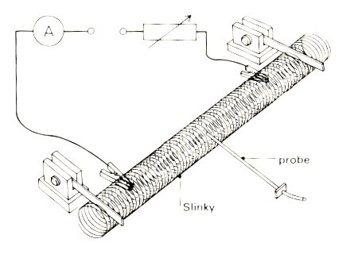

Use the equipment to investigate the following:

- How does the field vary along the axis? (Current and N/L constant)
- How does the field at the centre vary with current? (N/L constant)
- How does the field vary with number of turns per unit length (N/L)? (Current constant.)

Set of solenoids

You will need:
✓ Set of solenoids
✓ oscilloscope and search coil if using ac
✓ leads
✓ ruler
✓ transformer + 15 Ω rheostat or variable ac power supply + 5 A ac ammeter
✓ Alternative: smoothed dc power supply (or car battery) + rheostat, 5 A dc current meter and Hall probe

Set up
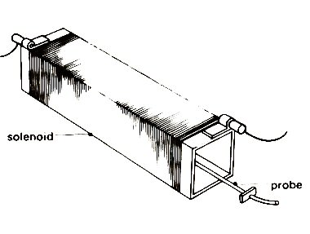

Use the equipment to investigate the following:

- How does the field vary along the axis? How does the field at the end compare to the centre?
- How does the field vary with current? (N/L constant)
- How does the field vary with number of turns per unit length? (N/L) (Current constant.) {Use a solenoid with closely wound turns and one with loose turns and compare results.}

Switch off equipment when not taking measurements.
Magnetic field board

You will need:
✓ Magnetic field board and 0.45 mm PVC covered wire or similar
✓ oscilloscope and search coil if using ac
✓ leads
✓ ruler
✓ transformer + 15 Ω rheostat or variable ac power supply + 5 A ac ammeter
✓ Alternative: smoothed dc power supply (or car battery) + rheostat, 5 A dc current meter and Hall probe

Set up

Wind circular coils on the board.

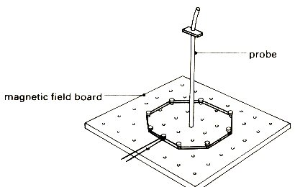

Use the equipment to investigate the following:

- How does the field at the centre vary with radius of coil? (constant current and number of turns)
- How does the field vary with current? (Radius and number of turns constant, measure the field at the centre of the coil)

Switch off equipment when not taking measurements

Make suitable notes and graphs of your results.

Straight wire

You will need:
✓ 0.45 mm PVC covered wire or similar
✓ 2 slotted bases
✓ 2 crocodile clips
✓ transformer + 15 Ω rheostat or variable ac power supply
✓ oscilloscope
✓ search coil
✓ leads
✓ ruler
✓ 5 A ac ammeter

(Alternative: use a signal generator with a high ac frequency rather than a power supply, but take care to limit the current so that the signal generator is not damaged.)

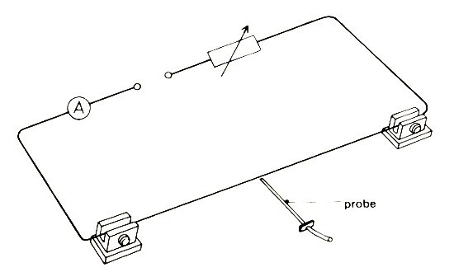

The longer the wire between the slotted bases the better. Make sure the rest of the equipment is some distance away.

Use the equipment to investigate the following:

- How does the field vary with distance from the wire? (constant current) Hint try 1/distance
- How does the field vary with current? (Have the probe close to the wire))

Remember to turn off equipment when it is not be used to take measurements

Practical advice
Search coils and Hall probes will need to be introduced as devices that give a reading proportional to field size
The set of coils and Slinky are alternative experiments
It is suggested that students report back on their experiment rather than carry out each task.
The straight wire is best with a signal generator set at a fixed high ac frequency together with the search coil. This allows smaller currents to be used and an easier experiment for students.

      | Turn power supplies off when not taking readings. Large current may be used, wires can get hot!

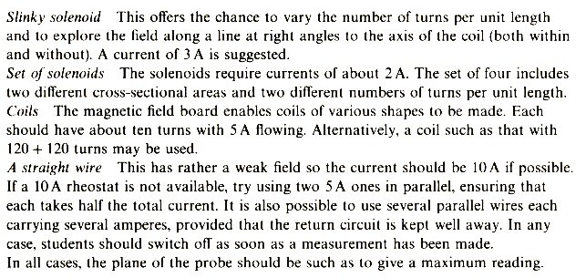
The advice for a straight wire above is for use with a Hall probe and dc.

External reference
This activity is taken from an adaptation of Revised Nuffield Advanced Physics experiment H7.

TAP 411- 5: Flux and flux density

1 Draw the magnetic field produced by a straight wire carrying a current.

2 Copy the following diagram and mark in the polarities of the two ends of the coil.

3. Copy the following diagram and mark in the compass directions.
wire

(a)

(b)

Question 4 take µ_{o} = 4π × 10⁻⁷ N A⁻²

4. Calculate the magnetic flux density at the following places:
(a) 2 m from a long straight wire carrying a current of 3 A
(b) at the centre of a solenoid of 2000 turns 75 cm long when a current of 1.5 A flows

5 A solenoid of length 25 cm is made using 100 turns of wire wrapped round an iron core. If the magnetic flux density produced when a current of 2 A is passed through the coil is
2.5 T calculate the permeability (µ) of the core.

6 A Hall probe measures a steady magnetic field directly by detecting the effect of the field on a slice of semiconductor material. A student sets up the circuit below to investigate, using a Hall probe, the factors which determine the magnetic flux density within a long solenoid.

6 Suggest and explain two ways of varying the magnitude of the flux density in the solenoid.

7. A solenoid similar to that shown in the diagram has 100 turns connected in a circuit over a length of 0.50 m. µ_{o} = 4π × 10⁻⁷ N A⁻²
Calculate the flux density at the centre of the solenoid when a current of 10 A flows.

Answers and worked solutions

1 2
N

S

3
wire
(resourcefulphysics.orA

(resourcefulphysics.org)

(a)

(b)

(resourcefulphysics.org)

4 (a) At distance r from a long straight wire: Magnetic flux density (B) = μ_{o}I / 2πr = 3 x 10⁻⁷ T

(b) At the centre of a solenoid: Magnetic flux density (B) = μ_{o}NI / L = 5.03 x 10⁻³ T

5 Magnetic flux density (B) = μNI / L = 2.5 = μ x 100 x 2 / 0.25 T
Permeability of the core (μ) = 2.5 x 0.25 / 100 x 2 = 0.0031 N A⁻²

6 Factors affecting field strength are current I and spacing of coils, N coils in length L:
$B∝I\text{, }B∝\frac{N}{L}$

7. Calculation using I = 30 A, N = 100, L = 0.50 m:
$$B=\frac{μ_{o}NI}{L}=\frac{4π×{\text{10}}^{−7}{\text{ N A}}^{\text{–2}}×\text{100}×\text{10}\text{ A}}{0\text{.}\text{50 m}}=2\text{.}5\text{ mT}$$

External references
Questions 1-5 of this activity are taken from Resourceful Physics
Questions 6 and 7 of this activity are taken from Advancing Physics chapter 15, 70S

